Module Name: Login Page - Functional & UI Test Cases
Test Case ID: st_01
Webpage URL: https://www.flipkart.com/

Step 1 : Open Application
Step 2 : Enter email Id/Mobile Number
Step 3 : Enter password/OTP
Step 4 : Click Login

Step 2 : Enter email Id/Mobile Number

Step 1 : Open Application

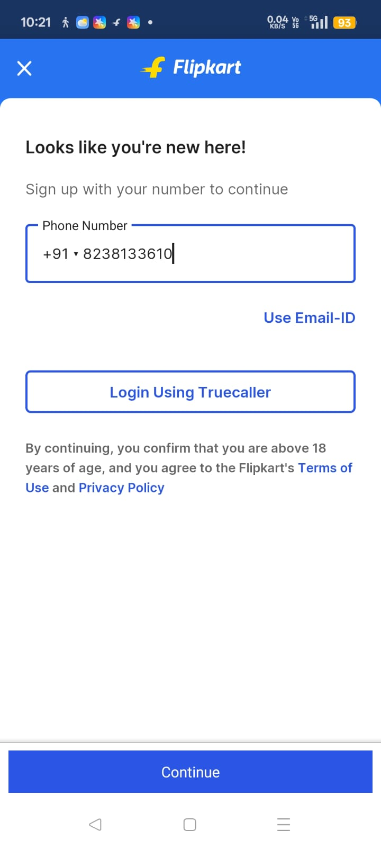
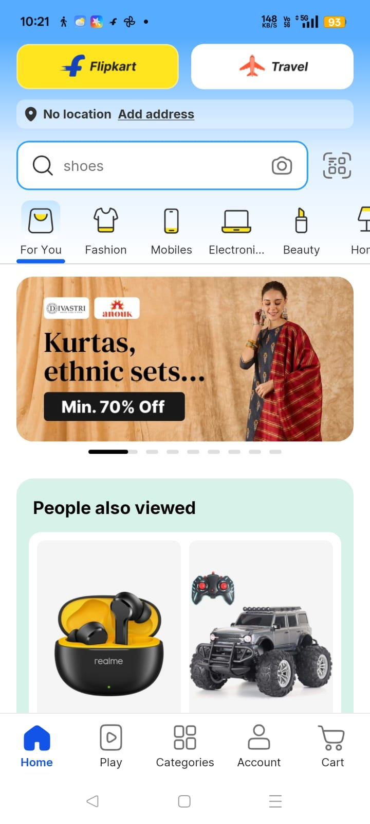

Step 3 : Enter password/OTP

Step 4 : Click Login

